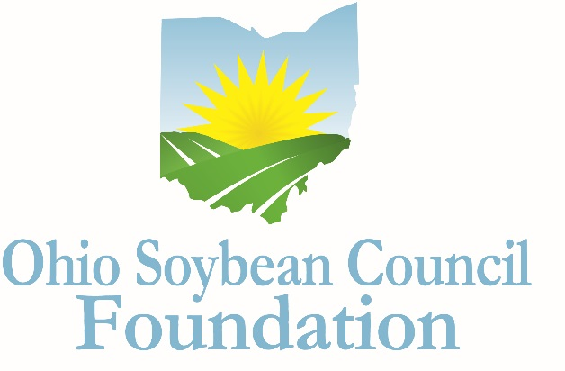

Ohio Soybean Council Foundation

Graduate Application
2018-2019

The future prosperity and long-term vitality of the American agricultural industry depend on science and technology. This program provides scholarships to graduate students at Ohio colleges and universities to help accelerate the application of science and technology to agricultural production.

Program
Three scholarships of up to $5,000 each are available to graduate students.

Eligibility
- Applicants must be enrolled as a full-time graduate student in an Ohio College or university program.
- Applicants must be conducting research in bioproducts, biobased materials, biotechnology, bioengineering, biopolymers or a related field, and focused on advancing the soybean industry.
- Applicants must have a grade point average of 3.0 or higher.
- Applicants must have proof of legal residency in the United States.
- Scholarship funds are to be used directly for tuition, fees, lab fees and books.
- Scholarship funds will be paid to the educational institution.
- Scholarship is not renewable, although recipients may reapply annually.

Selection Process
A Committee of Ohio Soybean Council board members and Ohio Soybean Council staff members will select scholarship winners. The Committee will request a personal interview of the final candidates, at the Ohio Soybean Council offices in Columbus (scheduled for February 19-21, 2018). Additional arrangements can be made for the interview process if there is a scheduling conflict with the final candidates (i.e. Skype). Scholarship recipients will be notified by March 5, 2018. The scholarship is to be used for the 2017-2018 school year.

Application
All applications must be typed, and must be received no later than Friday January 12, 2018.
Please include three recommendation letters, one regarding the applicant’s academic abilities; one regarding the applicant’s professional qualifications; and one that speaks to the applicant’s personal qualities. Letters must come from three different people. Letters may not be written by the applicant, anyone under 21 years of age, or anyone related to the applicant or serving as a legal guardian. Please include contact information for each reference.

About the Ohio Soybean Council Foundation
The Ohio Soybean Council Foundation is a 501(c)(3) non-profit organization dedicated to the improvement of the soybean industry through the support of scientific research and education. Scholarships will be awarded competitively based on merit and will be available on a nondiscriminatory basis without regard to race, color, creed, age, gender, disability, religion, sexual orientation, national origin, ancestry, or military or veteran.

Applicant Information

*Please type

Student Name

Home Address

Date of Birth
Citizenship
Phone Number

Email address

College Information

College or University

Address

Area of Concentration

Degree being pursued

Cumulative GPA

Month/Year of Expected Graduation

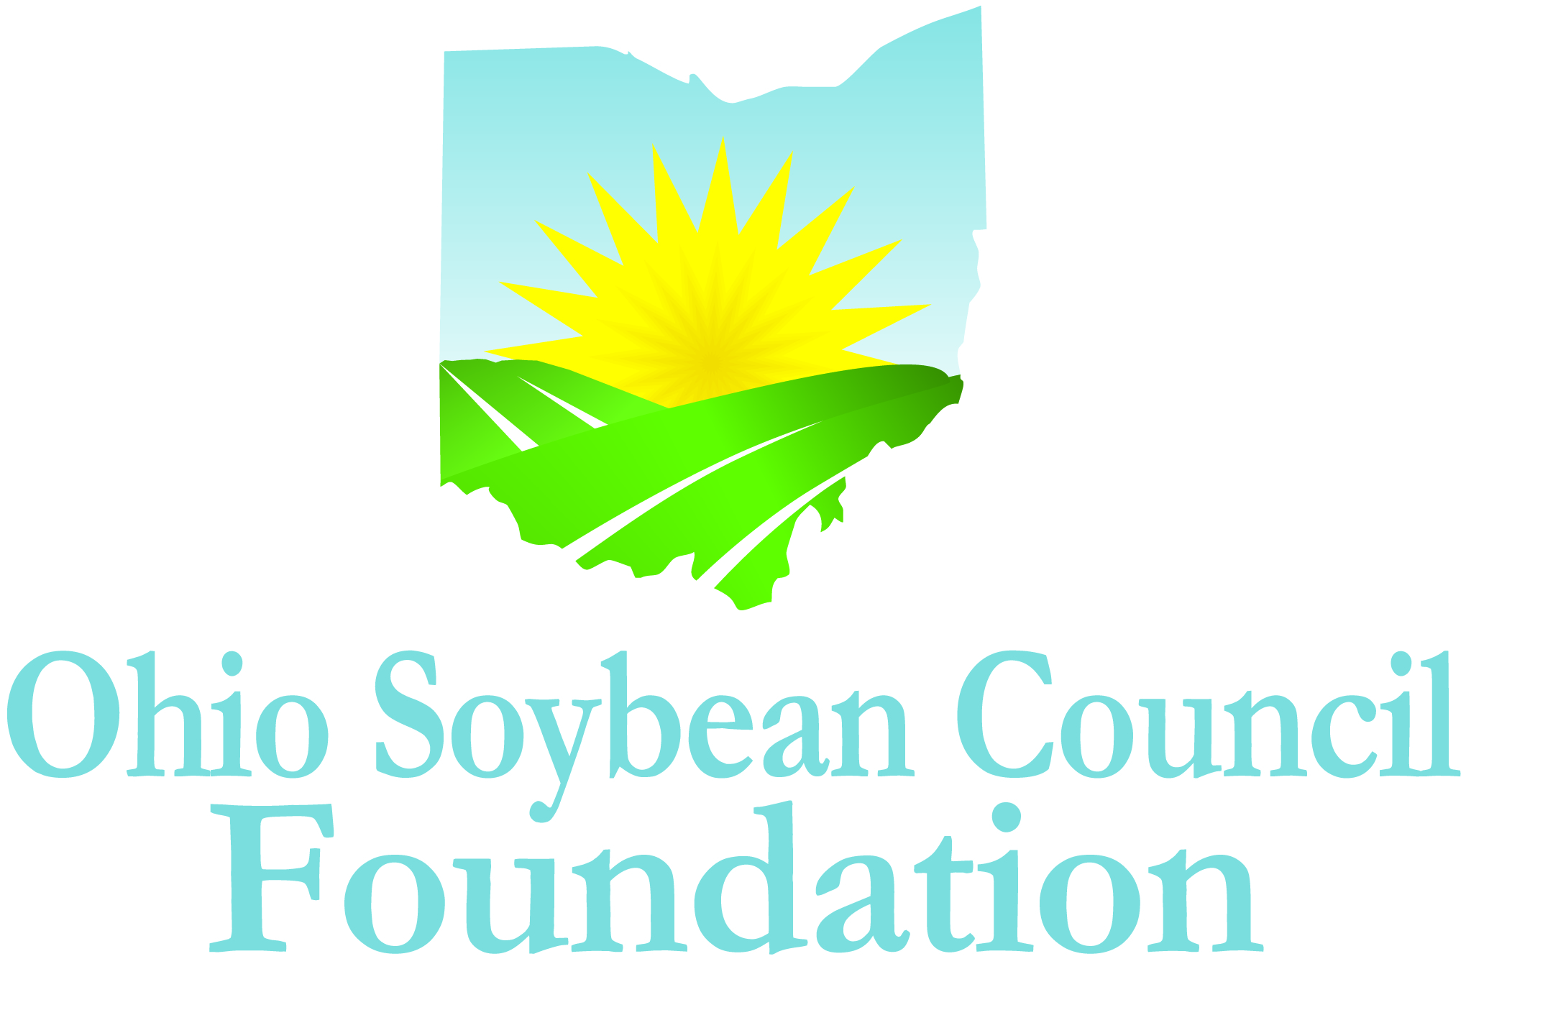

Extracurricular Activities
Please list your extracurricular activities, jobs and internships.

Volunteer and Community Activities
Please describe volunteer and community activities, including leadership roles you have held.

Awards and Honors
Please list awards and honors you have received.

Essay
Please answer the following question in 500 words or less: How will your chosen field of research contribute to the advancement of the soybean industry?

Scholarship Agreement
I affirm the information I have provided on this application is complete, accurate, and true to the best of my knowledge.
___________________________________________________________________________________
Applicant’s Signature Date

A complete application includes the following:

- Application (Extracurricular Activities; Community or Volunteer Activities; Awards and Honors/Essay)
- A copy of your official Transcript
- Three Letters of Recommendation

Mail completed application, along with a copy of your official transcript and letters of recommendation to:

Katie Bauer
Ohio Soybean Council Foundation
918 Proprietors Road Suite A
Worthington, Ohio 43085

DEADLINE: Must be received by January 12, 2018.

QUESTIONS?
Contact Katie Bauer, Communications and Project Coordinator, Ohio Soybean Council Foundation at kbauer@soyohio.org.

