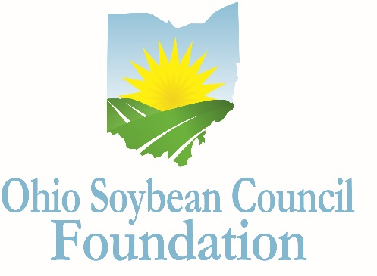

Ohio Soybean Council Foundation Scholarship

Undergraduate Application
2017-2018

In order to ensure the future prosperity of the U.S. soybean industry, it is important that students understand the wide variety of opportunities available in agricultural careers. The scholarship program encourages undergraduate students at Ohio colleges and universities to pursue degrees in one of the many academic fields that support the future of the soybean industry including agriculture, business, communication, economics, education, science and technology.
Program
Nine scholarships are available for undergraduate students who are current Ohio residents. Seven scholarship winners will receive up to $3,000 each, and one winner who is an agriculture business or communications major, will be awarded the $3,000 Farmer Lumpe+McClelland Scholarship. One winner will also be awarded the Bhima Vijayendran Scholarship, and will receive $5,000. The Bhima Vijayendran Scholarship was named to honor Dr. Vijayendran's significant contributions to the soybean industry through his scientific research and commercialization activities at Battelle Memorial Institute.
Eligibility
- Applicants must be enrolled as a full-time student at an Ohio college or university, and attained at least sophomore status by the fall of 2017, with a grade point average of 3.0 or higher.
- Eligible majors include biology, biochemistry, bioengineering, molecular biology, chemistry, engineering, biotechnology, bioenergy, biofuels, food science, crop science, environmental science, agricultural communications, agricultural business, agricultural education or any of the agricultural disciplines or related fields.
- Applicants must also demonstrate the desire to pursue a career related to the soybean industry and/or agriculture.
- Applicants must have proof of legal residency in the state of Ohio.
- Scholarship funds are to be used directly for tuition, fees, lab fees and books.
- Scholarship funds will be paid to the educational institution.
- Scholarship is not renewable, although recipients may reapply annually.
Selection Process
A Committee of Ohio Soybean Council board members and Ohio Soybean Council staff members will select scholarship winners. The Committee will request a personal interview of the final candidates, at the Ohio Soybean Council offices in Columbus (scheduled for February 22-24, 2017). Additional arrangements can be made for the interview process if there is a scheduling conflict with the final candidates (i.e. Skype). Scholarship recipients will be notified by March 6, 2017. The scholarship is to be used for the 2017-2018 school year.
Application
All applications must be typed, and must be received no later than Friday January 13, 2017.
Please include three recommendation letters, one regarding the applicant’s academic abilities; one regarding the applicant’s professional qualifications; and one that speaks to the applicant’s personal qualities. Letters must come from three different people. Letters may not be written by the applicant, anyone under 21 years of age, or anyone related to the applicant or serving as a legal guardian. Please include contact information for each reference.

Applicant Information

*Please type

Student Name

Home Address

Date of Birth
Citizenship
Phone Number

Email address

College Information

College or University

Address

Academic major

Academic minor

Cumulative GPA

Grade level in fall 2016

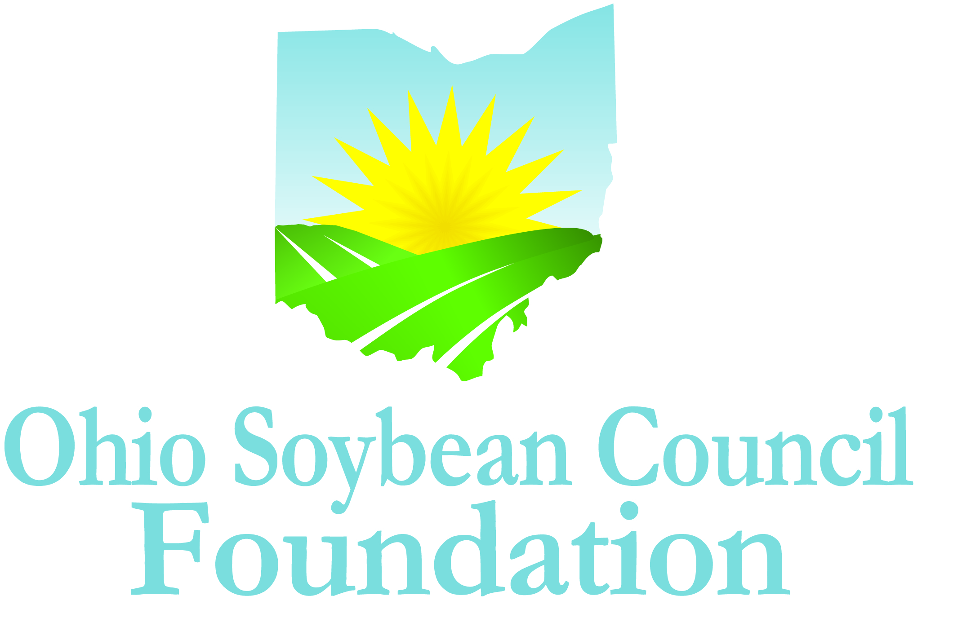

Extracurricular Activities
Please list your extracurricular activities, jobs and internships.

Volunteer and Community Activities
Please describe volunteer and community activities, including leadership roles you have held.

Awards and Honors
Please list awards and honors you have received.

Essay
Please answer the following question in 500 words or less: How will your chosen field of study contribute to advancing the soybean industry?

Scholarship Agreement
I affirm the information I have provided on this application is complete, accurate, and true to the best of my knowledge.
___________________________________________________________________________________
Applicant’s Signature Date

A complete application includes the following:

- Application (Extracurricular Activities; Community or Volunteer Activities; Awards and Honors/Essay)
- A copy of your official Transcript
- Three Letters of Recommendation

Mail completed application, along with a copy of your official transcript and letters of recommendation to:

Katie Bauer
Ohio Soybean Council Foundation
918 Proprietors Road Suite A
Worthington, Ohio 43085

DEADLINE: Must be received by January 13, 2017.

QUESTIONS?
Contact Katie Bauer, Communications and Project Coordinator, Ohio Soybean Council Foundation at kbauer@soyohio.org.

About the Ohio Soybean Council Foundation
The Ohio Soybean Council Foundation is a 501(c)(3) non-profit organization dedicated to the improvement of the soybean industry through the support of scientific research and education. Scholarships will be awarded competitively based on merit and will be available on a nondiscriminatory basis without regard to race, color, creed, age, gender, disability, religion, sexual orientation, national origin, ancestry, or military or veteran.

