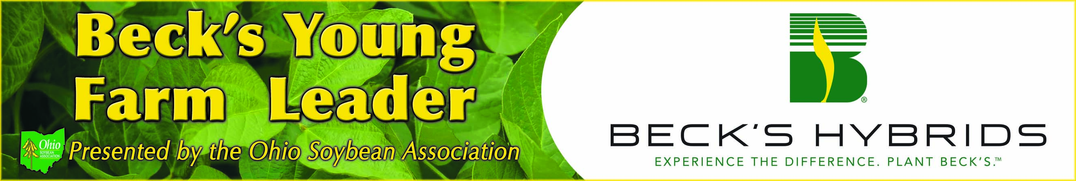
Overview

The Ohio Soybean Association (OSA) and Beck’s Hybrids share the belief that building a grassroots network of young agricultural leaders is important to the continued success of the soybean industry and all of Ohio agriculture. For this reason, OSA and Beck’s Hybrids have partnered to create the Beck’s Young Farm Leader Program to showcase the hard work, dedication and leadership of young Ohio farmers.

One farmer each quarter will be chosen by a selection committee consisting of OSA and Beck’s Hybrids representatives. Each farmer selected will be highlighted in a story published in several Ohio agricultural publications. The stories will focus on the individual’s leadership roles, both on and off the farm, and how he or she has built a foundation for farming success.

One of the Beck’s Young Farm Leaders will be selected as the 2014 Beck’s Young Farm Leader of the Year and receive a trip for two ($2,000 value) to the 2015 Commodity Classic in Phoenix, Arizona. Beck’s Young Farm Leaders may also be chosen to attend OSA and/or Beck’s Hybrids leadership training programs, board meetings, events and other relevant activities.

Guidelines

- Growers must be between the ages of 21 and 45.

- Any soybean grower may apply for the Beck’s Young Leader Program; selected participants are required to have a current Ohio Soybean Association membership.

- Applicants are not required to grow Beck’s Hybrids products to be eligible to win.

- Applicants should demonstrate an interest in pursuing leadership roles within the soybean industry.

Schedule
All applications postmarked by the following dates will be considered. Applications will carry over to subsequent quarters for consideration, but will not carry over to the 2015 Beck’s Young Farm Leader Program.

February 3, 2014: 1st Quarter Applications Due
May 1, 2014: 2nd Quarter Applications Due
August 1, 2014: 3rd Quarter Applications Due
October 31, 2014: 4th Quarter Applications Due

Applicants must complete the following application form and submit by mail to:

Ohio Soybean Association
Beck’s Young Farm Leader Program
918 Proprietors Road, Suite A
Worthington, Ohio 43085

Questions? Contact Adam Ward at award@soyohio.org or 614-476-3100.

Applicant Information
Name:
Date of birth:
Current address:
City: | State: | ZIP Code:
County: | Phone: |  | Fax:
Email:
Years Farming: | Acreage: | Livestock:
Describe Your Farming Operation:

Describe Your Current Off-Farm Activities:

Education and Training:

Describe your short-term and long-term goals as a soybean farmer:

What type of production and marketing programs do you utilize in your soybean operation?

What are the top issues you feel should be addressed to ensure the long-term profitability of the soybean industry?

Please describe leadership roles you have in your local community and/or agriculture organizations, as well as any future goals you would like to pursue:

If additional pages are needed, please attach.

