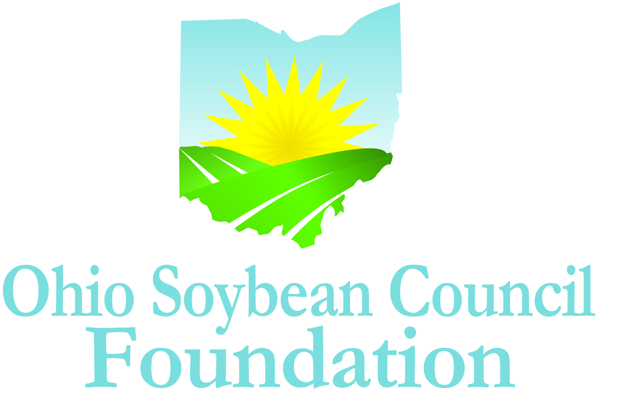
Ohio Soybean Council Foundation Scholarship Program
Graduate Students
2015-2016 Academic Year

The future prosperity and long-term vitality of the American agricultural industry depend on science and technology. This program provides scholarships to graduate students at Ohio colleges and universities to help accelerate the application of science and technology to agricultural production.

Two scholarships of up to $5,000 each are available to graduate students who are enrolled as a full-time student at an Ohio college or university, and have proof of legal residency in the United States. Applicants must be conducting research in bioproducts, biobased materials, biotechnology, bioengineering, biopolymers or a related field, and focused on advancing the soybean industry.

The Ohio Soybean Council Foundation is a 501(c)(3) non-profit organization dedicated to the improvement of the soybean industry through the support of scientific research and education. Scholarships will be awarded competitively based on merit and will be available on a nondiscriminatory basis without regard to race, color, creed, age, gender, disability, religion, sexual orientation, national origin, ancestry, or military or veteran status.

If you have any questions, please contact Katie Bauer, Program Coordinator, Ohio Soybean Council, by phone at (614) 476-3100, or by email at kbauer@soyohio.org.

SCHOLARSHIP AMOUNT

Two graduate student awards of up to $5,000 each
QUALIFICATIONS

- Applicant must be enrolled as a full-time graduate student in an Ohio college or university program.
- Applicant must be conducting research in bioproducts, biobased materials, biotechnology, bioengineering, biopolymers or a related field, and focused on advancing the soybean industry.
- Applicant must be focused on research that will result in the betterment of the soybean industry.
- Applicants must have proof of legal residency in the United States.
- Scholarship funds are to be used directly for tuition, fees, lab fees and books.
- Scholarship funds will be paid to the educational institution.
- Scholarship is not renewable, although recipients may reapply annually.
SELECTION PROCESS

A Committee of Ohio Soybean Council board members and Ohio Soybean Council staff members will select scholarship winners. The Committee will request a personal interview of the final candidates, at the Ohio Soybean Council offices in Columbus (tentatively scheduled for March 4-6, 2015). Additional arrangements can be made for the interview process if there is a scheduling conflict with the final candidates (I.e. Skype). The decision of the Committee is final.
\
GUIDELINES

All applications must be typed, and must be received no later than Friday January 16, 2015. Applications may be submitted by email or regular mail.

If you are submitting an application by email, please send the application and all applicable attachments to: Katie Bauer at kbauer@soyohio.org.

If you are submitting an application by regular mail, please mail the application and all applicable attachments to: Katie Bauer, Ohio Soybean Council Foundation, 918 Proprietors Road, Suite A, Worthington, Ohio 43085.
APPLICATIONS MUST INCLUDE AND WILL BE EVALUATED ON THE FOLLOWING:

Application
Transcripts
Three (3) Letters of Recommendation
Extracurricular Activities, Community or Volunteer Activities, Awards and Honors
Essay
APPLICATION DEADLINE

January 16, 2015 at 5 p.m. (EST)
AWARD NOTIFICATION

March 13, 2015.

APPLICANT INFORMATION

Name: ____________________________________________________________________________________________________

Home Address: ____________________________________________________________________________________________

City: ________________________________________ State: _______________________ Zip ____________________________

Phone Number: _____________________________ Email Address: _______________________________________________

Citizenship: ____________________________________ Date of Birth: ____________________________________________

Male _______ Female ___________

COLLEGE INFORMATION

College or University: _______________________________________________________________________________________

Address: ___________________________________________________________________________________________________

City: __________________________________________________________ Zip: ________________________________________

Area of Concentration: ____________________________________________________________________________________

Degree Being Pursued: ____________________ Month/Year of Expected Graduation: _________________________
APPLICANT TRANSCRIPT

You must submit your college transcript as part of a complete application.
LETTERS OF RECOMMENDATION

Three (3) Letters of Recommendation: One regarding the applicant’s academic abilities; one regarding the applicant’s professional qualifications; and one that speaks to the applicant’s personal qualities. Letters must come from three different people. Letters may not be written by the applicant, anyone under 21 years of age, or anyone related to the applicant or serving as a legal guardian. Please include contact information for each reference.

EXTRACURRICULAR ACTIVITIES

Please list your extracurricular activities, jobs and internships.

COMMUNITY OR VOLUNTEER ACTIVITIES

Please describe volunteer and community activities, including leadership roles you have held.

AWARDS AND HONORS

Please list awards and honors you have received.

ESSAY

Please answer the following question in 500 words or less: How will your chosen field of research contribute to the advancement of the soybean industry?

SIGNATURE

_____________________________________________ ____________________________________
Applicant’s Signature Date

