**Spring 2015**

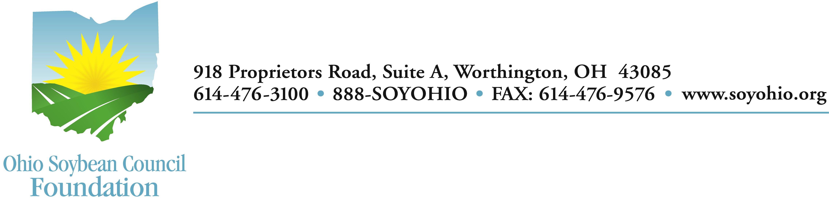

**District Science Day Awards**

Congratulations! Your science fair project has been chosen to receive one of the Ohio Soybean Council Foundation Science Awards for 2015. Your project met the criteria and was judged one of the “outstanding student projects in the area of agriculture biosciences, bioresources, biopolymers, bioproducts, and/or biofuels using soybeans.”

First, please complete and return the award form. Second, you are encouraged to share your successful project with others. Ask your teacher to help you go to [GrowNextGen.org](http://GrowNextGen.org) and Join the Network as a student. Click on the Resources menu, then Student Research, and UPLOAD A STUDENT RESEARCH PROJECT to the site. Our team is looking for innovative projects that feature soybeans, and your project may be chosen to be featured on GrowNextGen!

The Ohio Soybean Council is proud to support education and inquiry in the fields of science and engineering. You may wish to visit [www.soyohio.org](http://www.soyohio.org) to follow the entire District and State Science Day Winners and their projects. Best of luck to you as you continue your research and inquiry into the uses of soybeans.

Sincerely,



Tom Fontana

Director, Programs and Development

Name:__________________________________________________________

Project:_________________________________________________________