**Spring 2016**

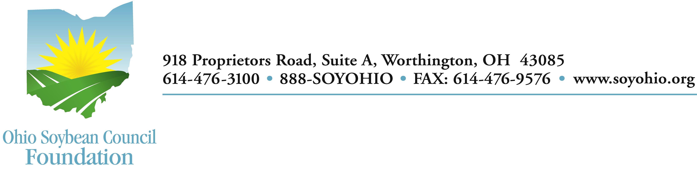

**District Science Day Awards**

Congratulations! Your science fair project has been chosen to receive one of the Ohio Soybean Council Foundation Science Awards for 2016. Your project met the criteria and was judged one of the “outstanding student projects in the area of agriculture biosciences, bioresources, biopolymers, bioproducts, and/or biofuels using soybeans.”

First, please complete and return the award form. Second, you are strongly encouraged to share your successful project with others via GrowNextGen.org, our online education platform. Publishing your research on our student research page will bring additional visibility to you and your research project. Simply e-mail Jane Hunt at [jane@educationprojects.org](mailto:jane@educationprojects.org) with your research paper, a signed copy of the attached parental permission form and two pictures of you or your project. One new feature on our site is that you can now also submit a 3-minute video of you introducing your project or demonstrating some aspect of your project. All students who submit their research by May 31 will be entered into a drawing for an additional $500 scholarship!

The Ohio Soybean Council is proud to support education and inquiry in the fields of science and engineering. You may wish to visit [www.soyohio.org](http://www.soyohio.org) to follow all of the District and State Science Day Winners and their projects. Best of luck to you as you continue your research and inquiry into the uses of soybeans.

Sincerely,

Tom Fontana

Director, Programs and Development

Name:__________________________________________________________

Project:_________________________________________________________