Components Guide for Soy Ohio

Hero Banners:

Hero Banner with Title, Hero Banner (Just without the white text)


Hero Banner with Tile and Title
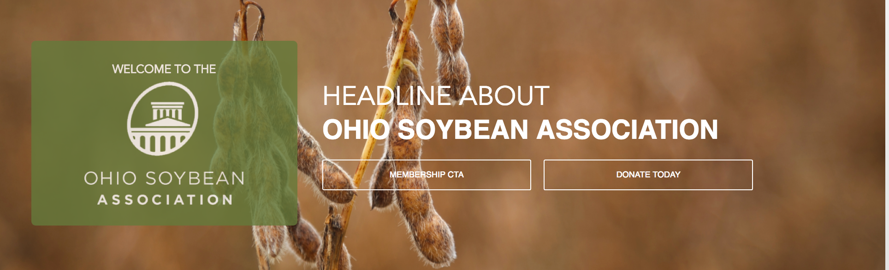

Hero Banner with Tiles
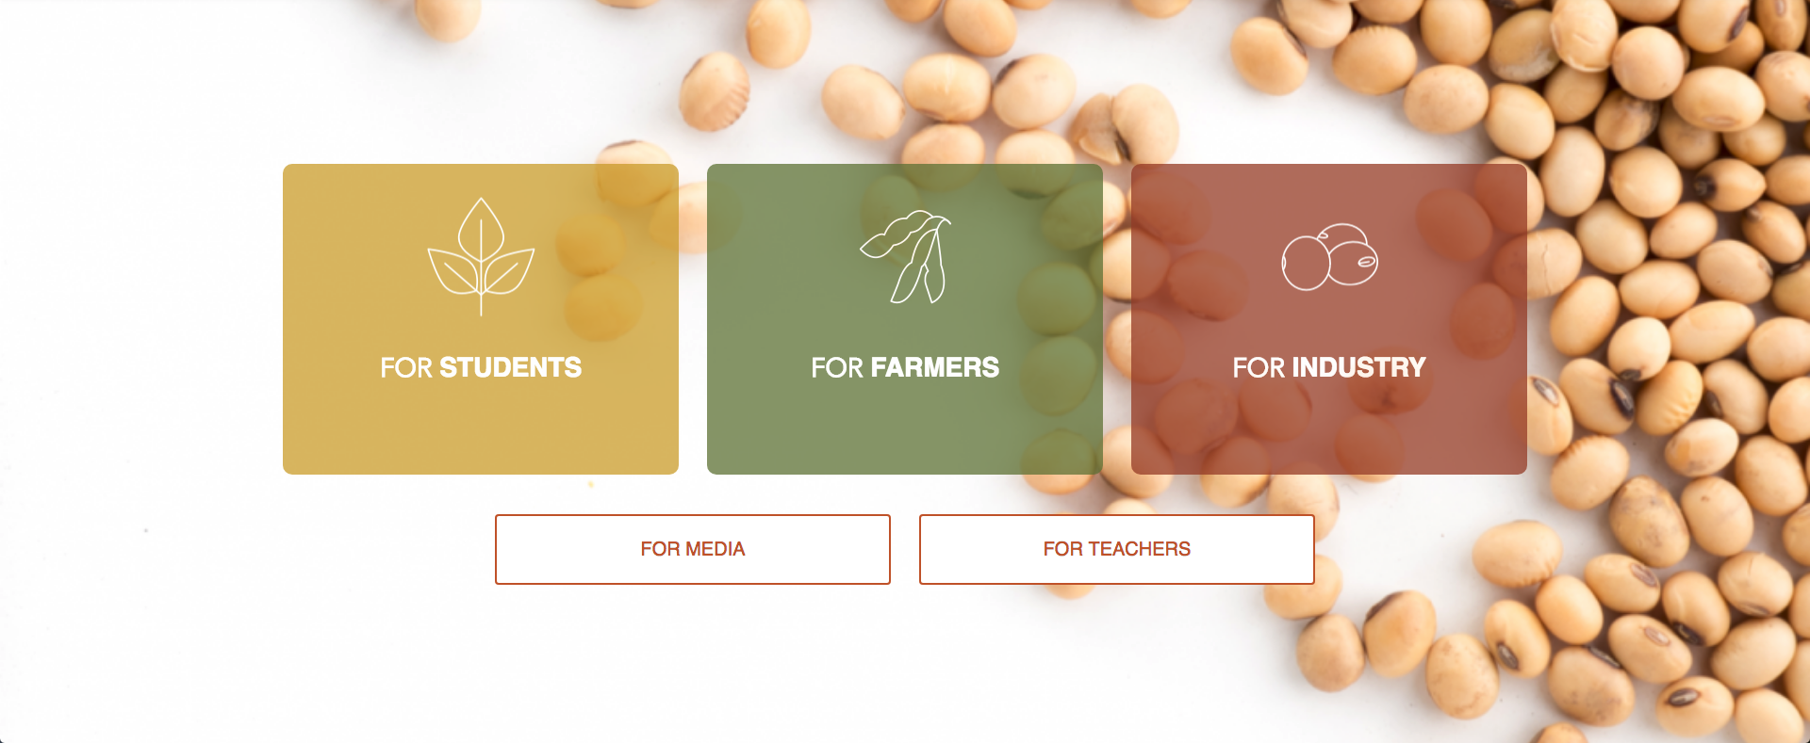

Hero Banner with Two Tiles


Subnavigation

Note: Hero Banner Slideshow contains all Hero Banners save for the Hero Banner with Tiles component and Subnavigation component
Components

Resources Block
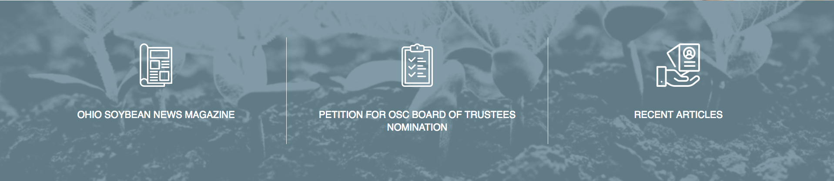

WYSIWYG
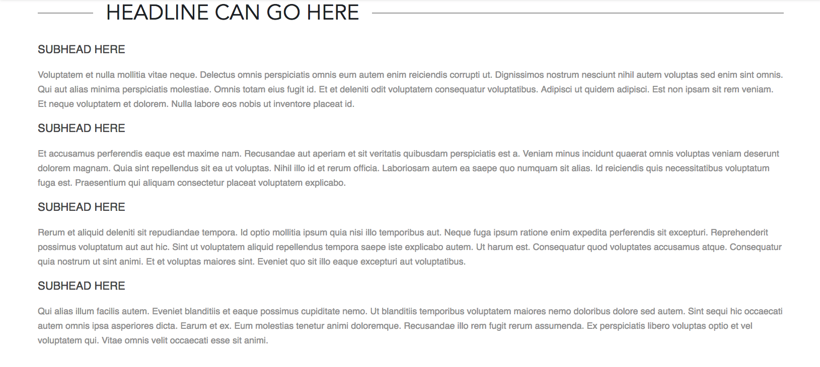

WYSIWYG with Image
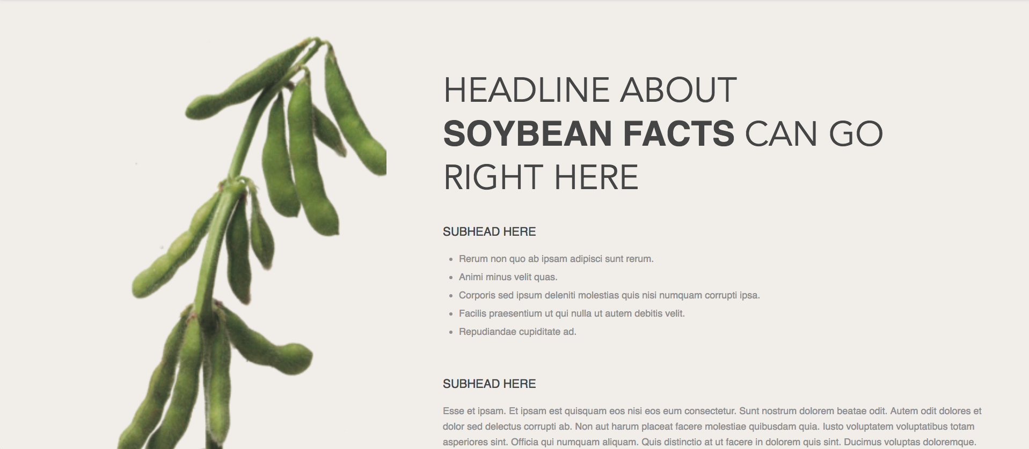

Content Overlay
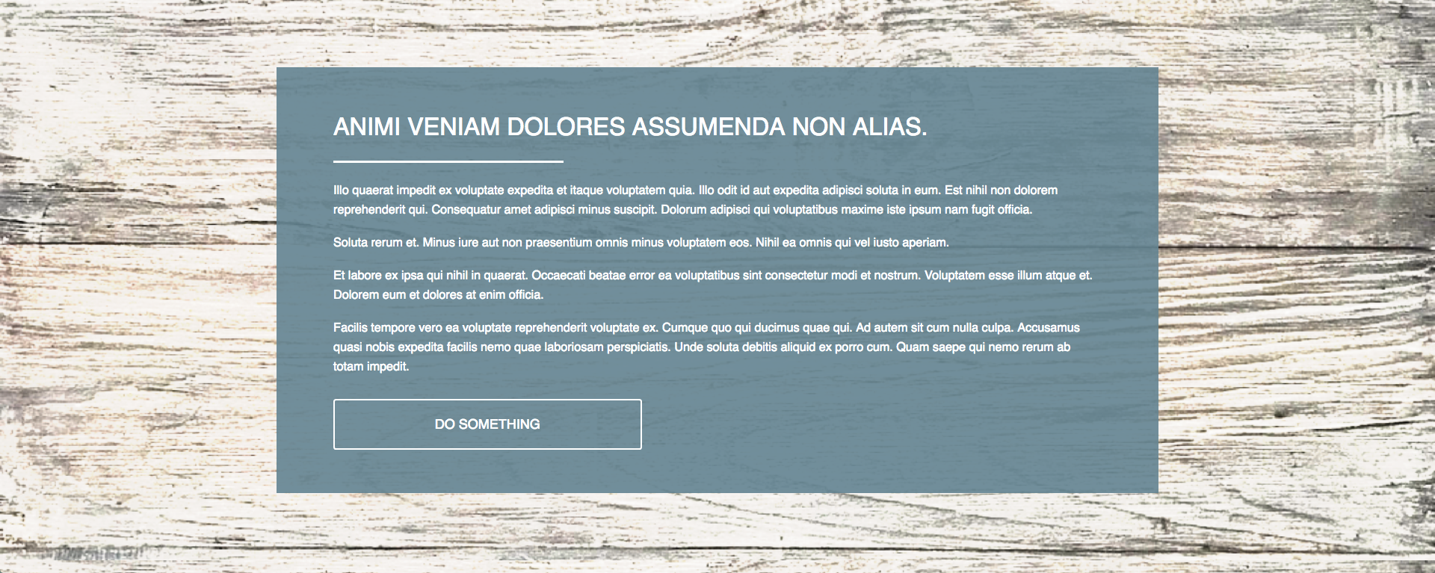

Content Overlay Slideshow
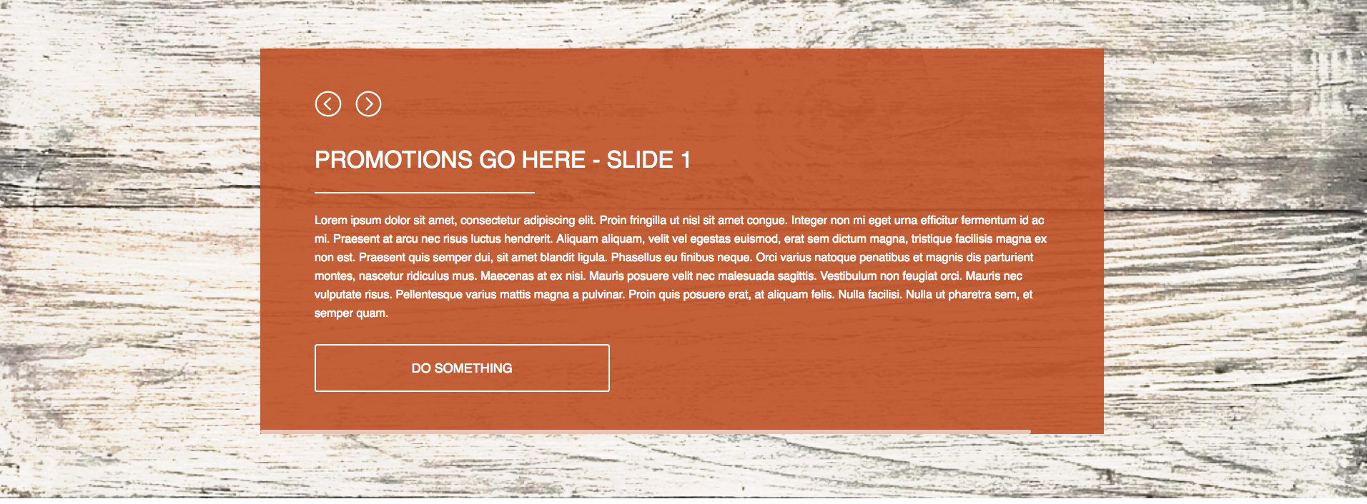

Side by Side Content Overlay
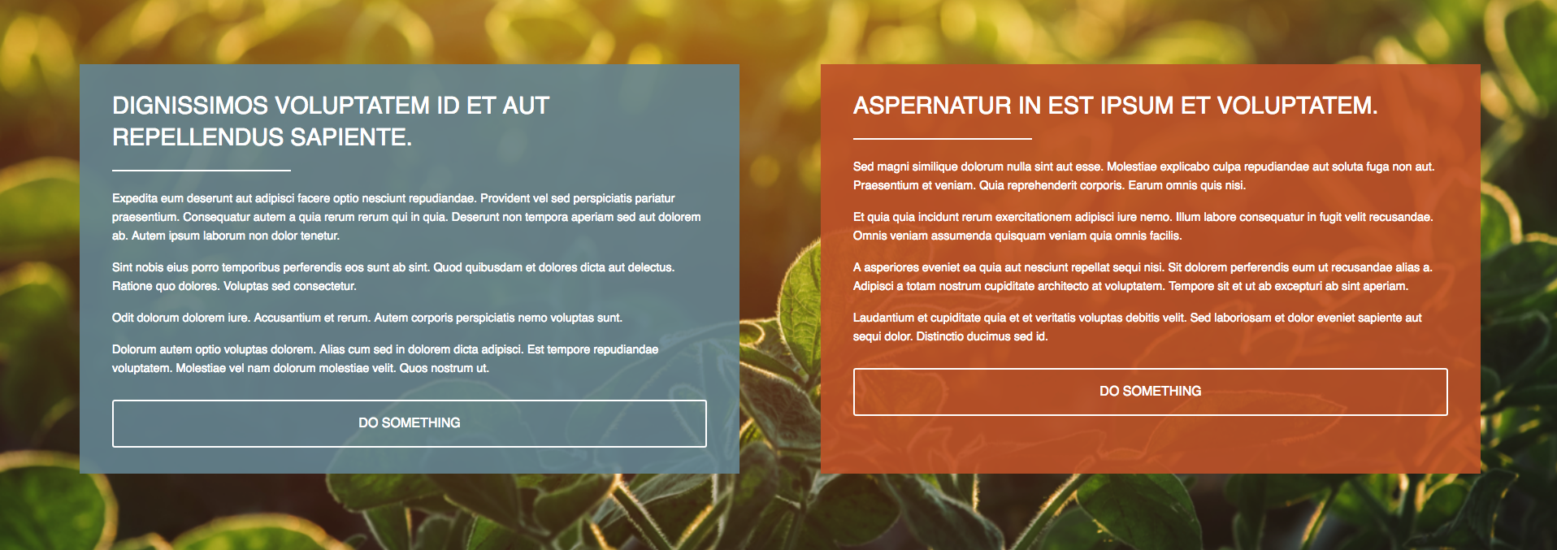

Content with Block Image
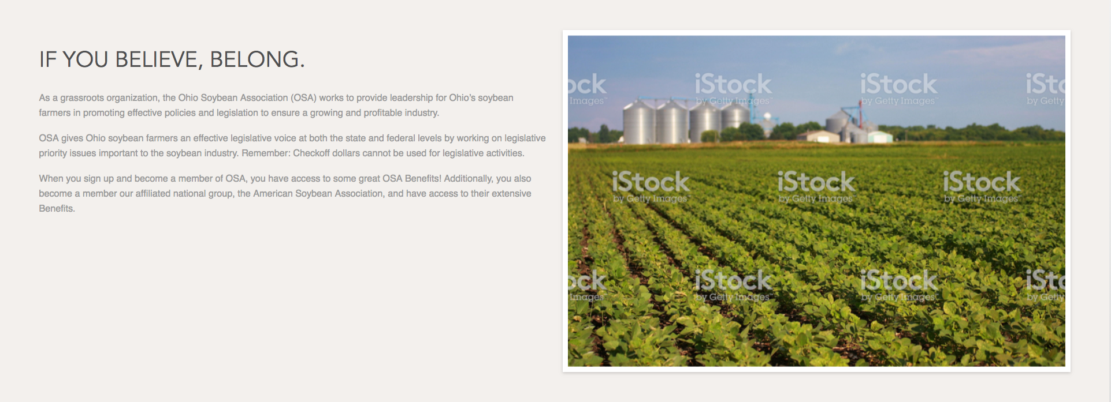

Horizontal Rule

Sponsor Logos
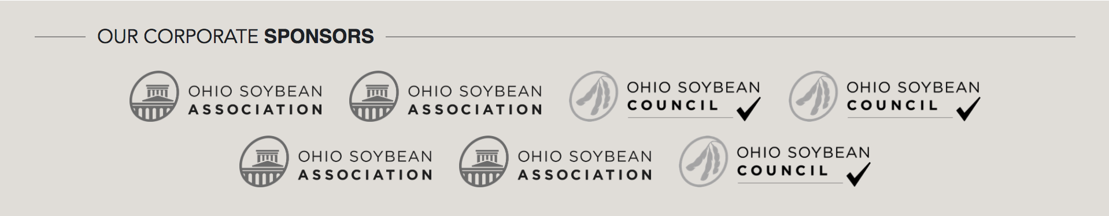

Content Overlay with Link List
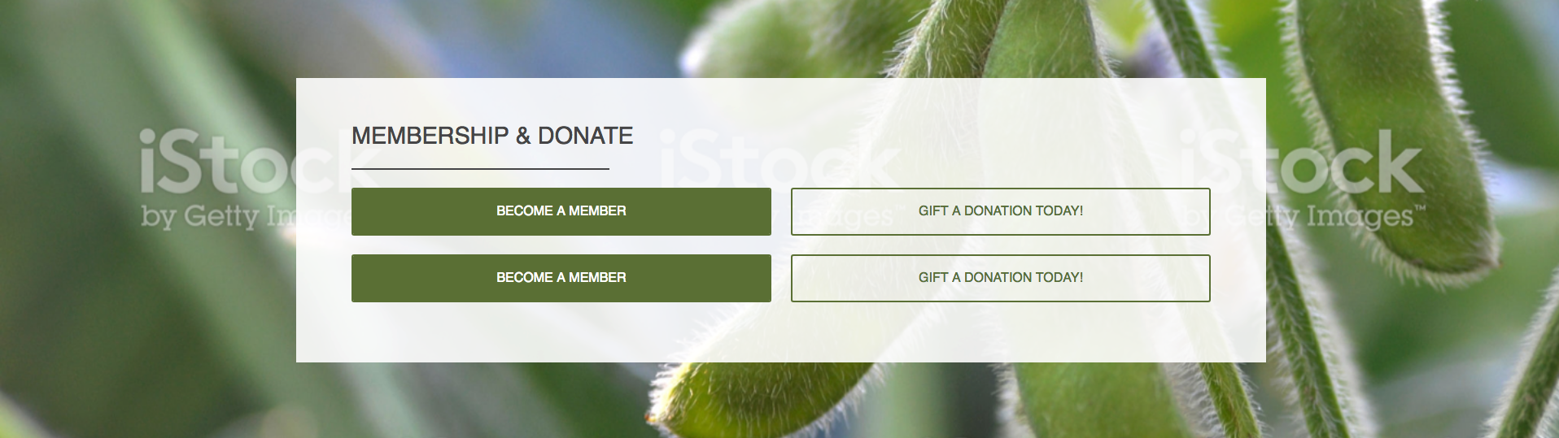

Two Column WYSIWYG
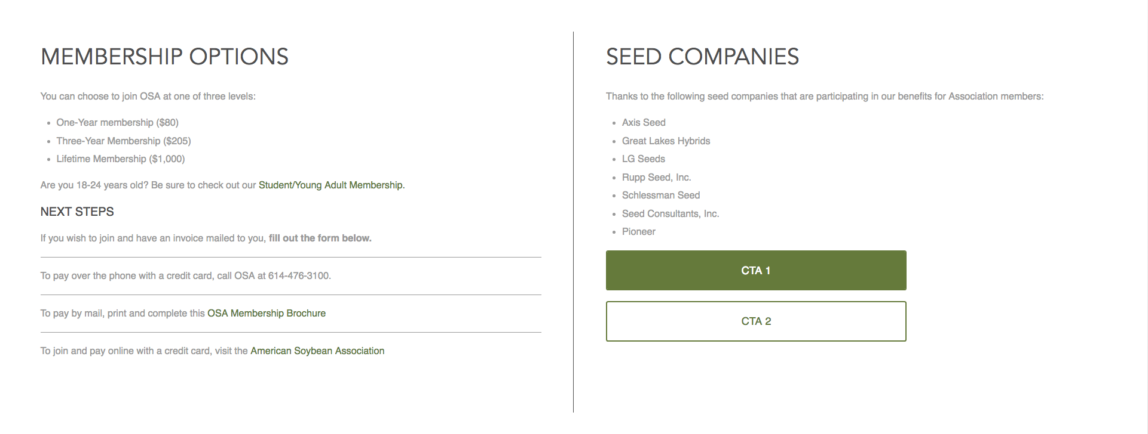
Form (Contact Us Example)
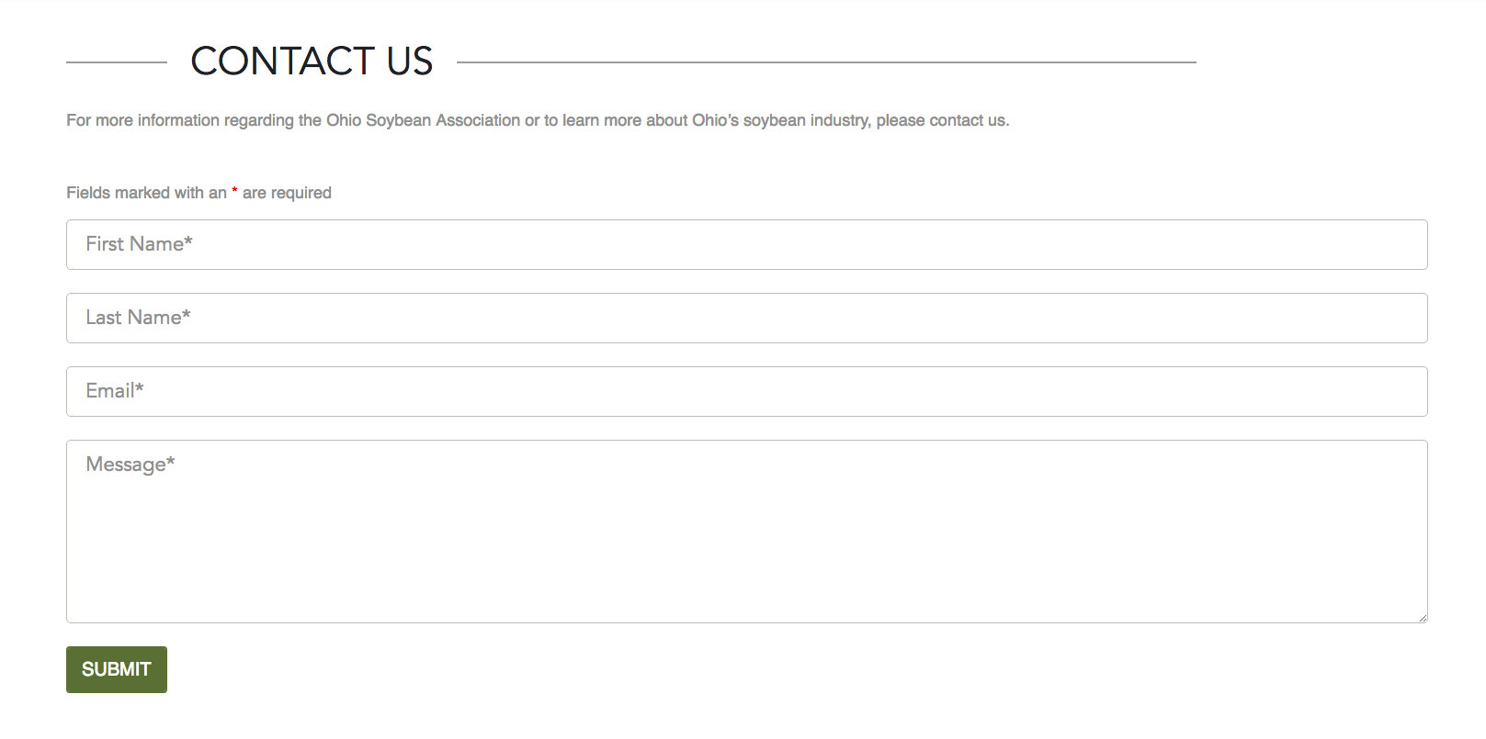

FAQ
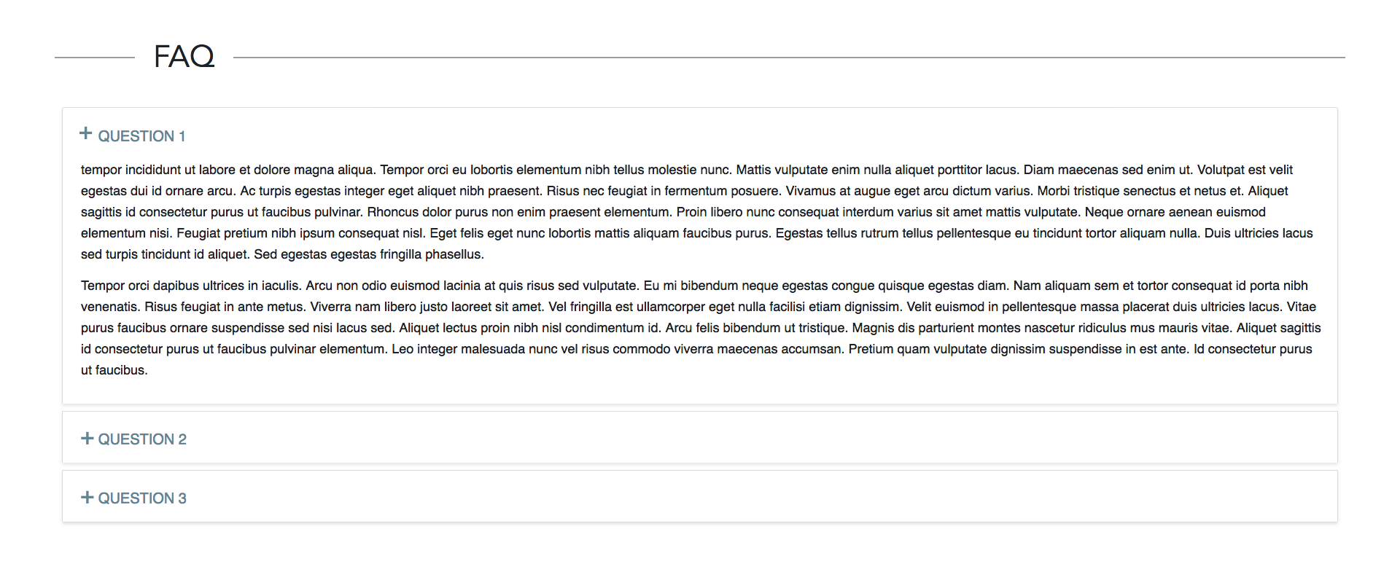
Content Tiles
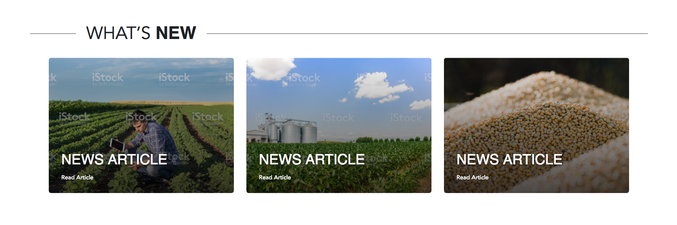

Tiles with Popup
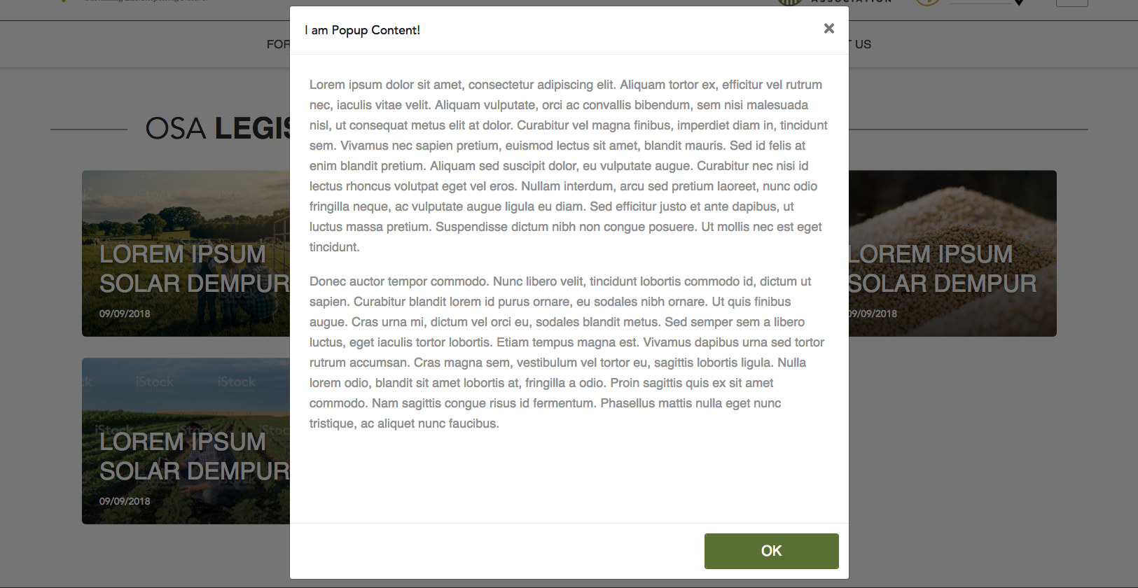

Image Wall
