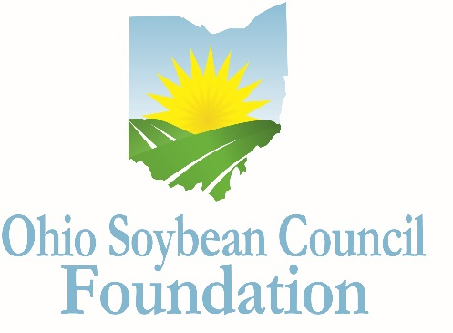

Ohio Soybean Council Foundation Scholarship

Undergraduate Application
2019-2020

In order to ensure the future prosperity of the U.S. soybean industry, it is important that students understand the wide variety of opportunities available in agricultural careers. The scholarship program encourages undergraduate students at Ohio colleges and universities to pursue degrees in one of the many academic fields that support the future of the soybean industry including agriculture, business, communication, economics, education, science and technology.

Program
Six undergraduate scholarships of up to $3,000 each will be awarded. In addition, one $3,000 FLM Harvest Excellence in Communications Scholarship, which was founded to provide resources to young people with a passion for agricultural communication or agricultural business will be awarded. Also available to one undergraduate student is a $3,000 Robinson W. Joslin Scholarship, which was established to recognize a student who has demonstrated outstanding leadership potential. Lastly, one undergraduate student is eligible for a $5,000 Bhima Vijayendran Scholarship, named to honor Dr. Vijayendran’s contributions to the soybean industry through his scientific research and commercialization activities at Battelle. This scholarship was founded to support those pursuing a degree related to science, technology or soybean research.
Eligibility
- Applicants must be enrolled as a full-time student at an Ohio college or university, and attained at least sophomore status by the fall of 2019, with a grade point average of 3.0 or higher.
- Eligible majors include biology, biochemistry, bioengineering, molecular biology, chemistry, engineering, biotechnology, bioenergy, biofuels, food science, crop science, environmental science, agricultural communications, agricultural business, agricultural education or any of the agricultural disciplines or related fields.
- Applicants must also demonstrate the desire to pursue a career related to the soybean industry and/or agriculture.
- Applicants must have proof of legal residency in the state of Ohio.
- Scholarship funds are to be used directly for tuition, fees, lab fees and books.
- Scholarship funds will be paid to the educational institution.
- Scholarship is not renewable, although recipients may reapply annually.
Selection Process
A Committee of Ohio Soybean Council board members and Ohio Soybean Council staff members will select scholarship winners. The Committee will request a personal interview of the final candidates, at the Ohio Soybean Council offices in Columbus (scheduled for February 12-14, 2019). Additional arrangements can be made for the interview process if there is a scheduling conflict with the final candidates (i.e. Skype). Scholarship recipients will be notified by March 4, 2019. The scholarship is to be used for the 2019-2020 school year.
Application
All applications must be typed, and must be received no later than Friday January 11, 2019.
Please include three recommendation letters, one regarding the applicant’s academic abilities; one regarding the applicant’s professional qualifications; and one that speaks to the applicant’s personal qualities. Letters must come from three different people. Letters may not be written by the applicant, anyone under 21 years of age, or anyone related to the applicant or serving as a legal guardian. Please include contact information for each reference.

Applicant Information

*Please type

Student Name

Home Address

Date of Birth
Citizenship
Phone Number

Email address

College Information

College or University

School Address

Academic major

Academic minor

Cumulative GPA

Grade level in Fall 2019

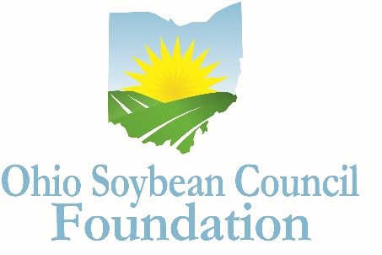
How did you hear about this scholarship? _______________________

Extracurricular Activities
Please list your extracurricular activities, jobs and internships.

Volunteer and Community Activities
Please describe volunteer and community activities, including leadership roles you have held.

Awards and Honors
Please list awards and honors you have received.

Essay
Please answer the following question in 500 words or less: How will your chosen field of study contribute to advancing the soybean industry?

Scholarship Agreement
I affirm the information I have provided on this application is complete, accurate, and true to the best of my knowledge.
___________________________________________________________________________________
Applicant’s Signature Date

A complete application includes the following:

- Application (Extracurricular Activities; Community or Volunteer Activities; Awards and Honors/Essay)
- A copy of your official Transcript
- Three Letters of Recommendation

Mail completed application, along with a copy of your official transcript and letters of recommendation to:

Julia Brown
Ohio Soybean Council Foundation
918 Proprietors Road Suite A
Worthington, Ohio 43085

DEADLINE: Must be received by January 11, 2019.

QUESTIONS?
Contact Julia Brown, Communications and Project Coordinator, Ohio Soybean Council Foundation at jbrown@soyohio.org.
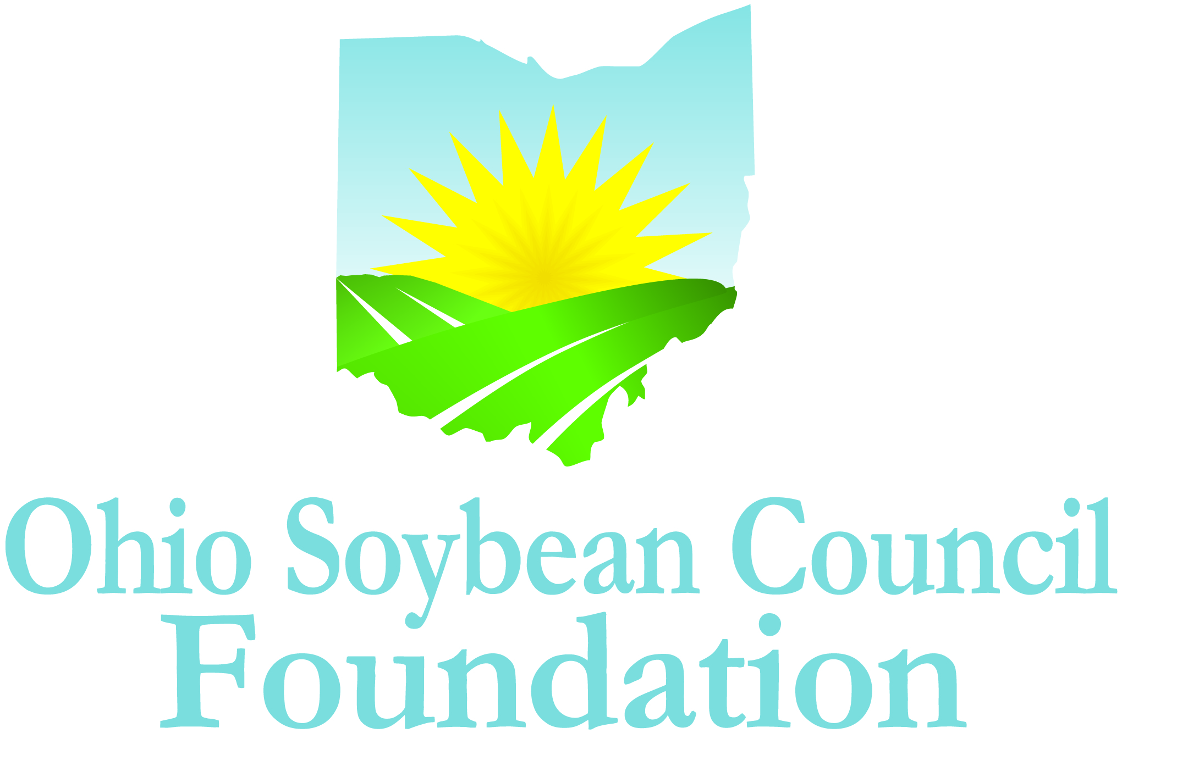

About the Ohio Soybean Council Foundation
The Ohio Soybean Council Foundation is a 501(c)(3) non-profit organization dedicated to the improvement of the soybean industry through the support of scientific research and education. Scholarships will be awarded competitively based on merit and will be available on a nondiscriminatory basis without regard to race, color, creed, age, gender, disability, religion, sexual orientation, national origin, ancestry, or military or veteran.

